**Crypto Challenges**

**Challenge 1**

This first puzzle is pretty straightforward. You even get the key. Use it to decipher the questions and then choose the right answer.

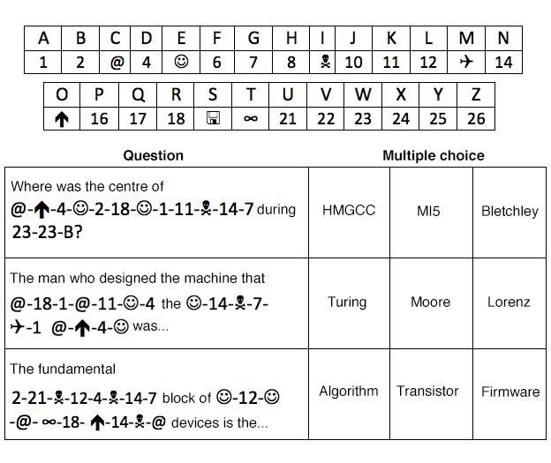

**Challenge 2**

**This time there is no key to help decipher this short string of numbers, so it is a bit harder. However, here is a hint - once deciphered the string will reveal the name of a famous maths code that uses numbers.**

**5 8 1 14 13 0 2 2 8 18 4 16 20 4 13 2 4**



**There is a clue to the answer for Challenge Two in this photograph.**

**Challenge 3**

**Code-breaking was practised in Roman times: Julius Caesar was known to use a code to securely send messages to his armies. This message uses a type of cipher named after the general to conceal its meaning. When you crack it you will find out where he kept his armies.**

**X S K L V V O H H Y L H V**

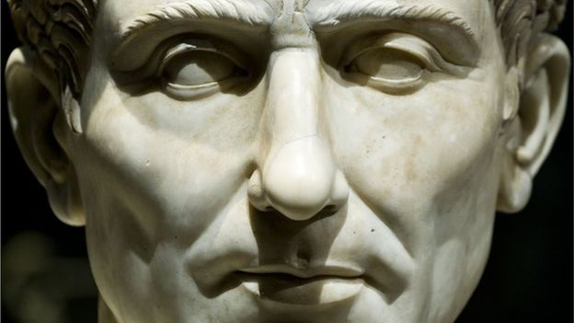

**It's no joke that Caesar used ciphers to conceal messages to his troops**

**Challenge 4**

**Title :** 4, 4, 2, 5, 5, 5, 8, 8...

This is a quote by a very famous person. Can you decipher it? I won't include capitals in the cipher.

"oltsitemsienevfruodngania."

-ebjnmanirfnalkni

### **Hint**

**The title is a clue, and the last three letters in the quote are different.**

**Challenge 5**

What does this message say?

G T Y O R J O T E O U I A B G T

(Look into Caesar Box)

**Challenge 6**

**Justin Case and Auntie Bellum are fellow con artists who deliver coded messages to each other to communicate. Recently Auntie Bellum was put in jail for stealing a rare and expensive diamond. Only a few days after this, Justin Case sent her a friendly letter asking her how she was. On the inside of the envelope of the letter, he hid a code. Yesterday, Auntie Bellum escaped and left the envelope and the letter inside the jail cell. The police did some research and found the code on the inside of the envelope, but they haven't been able to crack it. Could you help the police find out what the message is?**

**This is the code:**

**Llwatchawtfeclocklnisksundialcirbetimersool**

### Hint

**It was a TIMED escape.**

**Challenge 7**

This one is a real step up in difficulty. It can probably be done by trial and error, but it will be quicker to work out the rules governing the substitution and apply them. The key to cracking the message is elementary and you may find it easier to sit at a table rather than a desk to crack it.

Breaking the cipher will reveal a question. The solution is the answer to that question.

81, 1, 68, 59, 68, 86, 53, 76, 105, 53, 24, 22, 89, 5, 57, 68, 77, 50, 89, 81, 85, 4, 113, 71, 95, 86, 47, 44, 45, 33, 11, 64, 99, 12, 63, 10, 73, 8, 87, 52, 67, 68, 24, 72, 63, 25, 77, 6, 13, 3, 68, 57, 63, 101, 99, 60, 43, 14, 76, 88, 64, 47, 7, 53, 50, 99, 66, 76, 60, 22, 1, 99, 5, 47, 62, 53, 106, 8, 9, 81, 2, 68, 53, 75, 89, 52, 8, 25, 77, 27, 28, 113, 42, 4, 63, 75, 34, 63, 71, 63, 27, 52, 88, 76, 11, 17, 8, 11, 26, 77, 32, 113, 45, 13, 52, 77, 76, 11, 14, 13, 11, 66, 44, 63, 6, 115, 44, 37, 77, 7, 31, 6, 67, 63, 42, 77, 17, 13, 57, 84, 45, 8, 15, 63, 86, 43, 77, 68, 62, 74, 68, 23, 63, 92, 14, 68, 66, 53, 22, 52, 8, 24, 44, 68, 13, 81, 63, 18, 17, 53, 46, 72, 68, 44, 83, 39, 92, 62, 77, 28, 31, 52, 67, 63, 53, 28, 77, 43, 53, 13, 3, 3, 68, 65, 43, 63, 45, 34, 8, 26, 73, 67, 63, 68, 3, 63, 42, 68, 60, 65, 21, 4, 92, 73, 52, 74, 8, 57, 68, 65, 43, 63, 44, 38, 20, 13, 10, 52, 5, 63, 92, 50, 68, 66, 74, 67, 13, 81, 33, 75, 68, 81, 80, 63, 70?



The appliance of science should help crack this message

<https://www.bbc.com/news/technology-35929741>

**Challenge 8**

There was a death on Treebark Ln. The victim was identified as Mark Oswalt, who recently was married. The police went to the crime scene and they reported the death as a suicide.

Later that day, after the police left, a private detective, hired by the victim's friend who thought it was a murder, searched the crime scene and found a note the police missed.

It read,

"4,3: 8,1:_: 9,1: 2,1: 7,4:_: 6,1:9,3:_: 9,1: 4,3: 3,3: 3,2: !"

The detective took out his cell phone and started dialing the police to tell them about his findings. Once the detective opened the phone to dial, he immediately screamed out, "I SOLVED IT!"

Who was the murderer and how did the detective find out?

**Challenge 9**

Good work if you have got this far. This final challenging set of puzzles has three parts; when each one is completed it will reveal a quote from a well-known work of literature, whose author loved intellectual games of all kinds. Can you find all three?

Bear in mind while you are working on these that each puzzle is not necessarily just a cipher - there are some computer science basics mixed in. Each one is designed to be solved independently so if one of the puzzles defeats you then move on. Here's one final clue: Alice fell down a rabbit hole and left clues so Bob could find her...

